HR Analytics Dashboard – Employee Attrition & Workforce Insights (Power BI Project)

Problem Objective
To Help an organization to improve employee performance and improve employee retention
(reduce attrition) by creating a HR Analyst dashboard. The dashboard provides actionable insights into employee turnover, salary distribution, demographics, and job role impact — enabling HR teams and business leaders to make data-driven retention and workforce planning decisions.

2. Business Problem
Employee attrition significantly impacts organizational cost, productivity, and morale.
This dashboard aims to:
- Identify key drivers behind employee attrition
- Analyze attrition by age, salary, education, and job role
- Provide HR decision-makers with interactive workforce insights
- Support data-driven retention strategies

3. Key KPIs Tracked
- 👥 Total Employees: 1470
- 🔄 Attrition Count: 237
- 📉 Attrition Rate: 16.1%
- 🎂 Average Age: 37
- 💰 Average Salary: 6.5K
- 🏢 Average Years at Company: 7.0

4. Dashboard Features

🔹 Attrition Analysis By:
- Education Background
- Age Group
- Salary Slab
- Years at Company
- Job Role
- Gender Distribution

🔹 Visual Components:
- KPI Cards
- Donut Chart (Education-wise Attrition)
- Bar Charts (Job Role & Salary Slab)
- Line Chart (Years at Company Trend)
- Interactive Filters & Drill-through

5.Dax
Attrition Rate = sum(HR_Analytics[Attrition Count])/sum(HR_Analytics[EmployeeCount])

6. Tools & Technologies Used
- Power BI
- DAX (Data Analysis Expressions)
- Data Modeling
- Data Cleaning & Transformation
- Interactive Data Visualization
- Conditional Column

7. Insights Derived
- Highest attrition observed in mid-career age groups.
- Lower salary slabs show higher attrition rates.
- Sales and Research roles show comparatively higher turnover.
- Employees with fewer years at company exhibit higher attrition risk.

8. Dashboard Preview

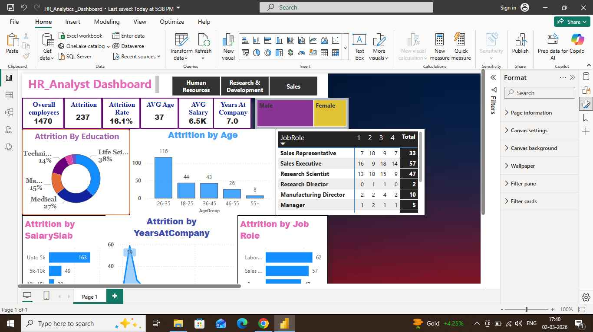

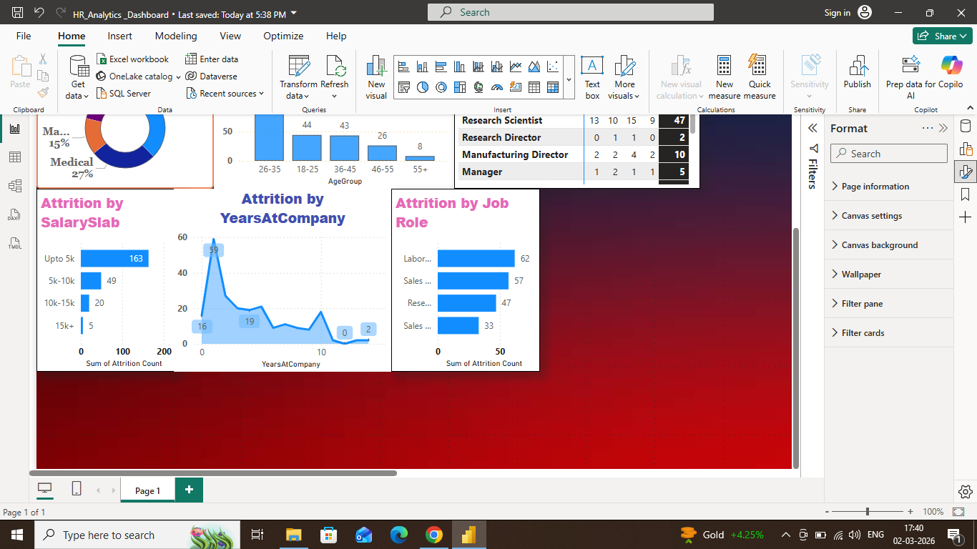

9. File Included
- HR_Analytics_Dashboard.pbix
- Dataset .csv
- Dashboard Screenshot

10. Skills Demonstrated
- Business Intelligence Reporting
- HR Data Analysis
- Data Storytelling
- KPI Development
- Dashboard Design Principles
- Analytical Thinking

11. About Me
Aspiring Data Analyst passionate about transforming raw data into actionable insights through visualization and business intelligence tools.
12.Project Learning
- Identified key factors to reduce attrition
- Improved the hiring process
- Improved employee experience
- Made work more productive
- Gained employee trust

13. Business Recommendations
- Improve Early Employee Retention: Strengthen onboarding and mentorship programs to reduce attrition among employees with fewer years at the company.
- Review Compensation Strategy: Reassess salary structure for lower pay bands and introduce performance-based incentives to improve retention.
- Focus on High-Attrition Roles: Implement targeted engagement and workload management strategies for Sales and Research roles.
- Enhance Career Growth Opportunities: Provide clear promotion paths, skill development programs, and internal mobility options to retain mid-career employees.
These actions can help reduce attrition, improve employee satisfaction, and lower hiring and training costs.

Deepak Kumar Tekchandani
Power BI|DAX (Data Analysis Expressions)|Data Modeling|Data Cleaning & Transformation|Interactive Data Visualization
📧 deepakkumartekchandani@gmail.com
🔗 LinkedIn: www.linkedin.com/in/deepak-kumar-tekchandani-b7200a146
💻 GitHub: https://github.com/DTekchandani1/HR-Analytics-Dashboard-Employee-Attrition-Workforce-Insights-Power-BI-Project-.git
👉

